**Wildanul Ahsan**

**Git Fundamental**

**Tugas 14**

wildanul08@gmail.com

05/12/2022

Buatlah folder dengan nama **eduwork-git-nama_kalian,** lalu buatlah file dengan extensi .txt berjumlah 2 file yang mana masing-masing sudah ada isi atau kontent. Lalu, lakukan perintah berikut ini:

1. Salah satu file ubah konten asli menjadi kalimat **“Saya belajar git”** lalu push
2. Buat branch baru dengan nama **“mytask”** lalu checkout ke branch tersebut
3. Ubah isi konten di file yang kedua dengan kalimat apapun dan buatlah 1 file lagi dengan extensi .php dimana isi kontennya **“<?php phpinfo(); ?>”** lalu push

Checkout ke branch *main* dan jangan lupa **merge** point 3 yaitu dari branch ***mytask*** ke branch ***main*** lalu push.

wilda@Wildanul-Ahsan MINGW64 /d/Free Class SQA eduwork/Tugas14 - Git Fundamental/Eduwork-Git-Wildanul_Ahsan

$ git init

Initialized empty Git repository in D:/Free Class SQA eduwork/Tugas14 - Git Fundamental/Eduwork-Git-Wildanul_Ahsan/.git/

wilda@Wildanul-Ahsan MINGW64 /d/Free Class SQA eduwork/Tugas14 - Git Fundamental/Eduwork-Git-Wildanul_Ahsan (master)

$ git remote add origin https://github.com/wildanul12/LearnGit12.git

wilda@Wildanul-Ahsan MINGW64 /d/Free Class SQA eduwork/Tugas14 - Git Fundamental/Eduwork-Git-Wildanul_Ahsan (master)

$ git add kontent1.txt

wilda@Wildanul-Ahsan MINGW64 /d/Free Class SQA eduwork/Tugas14 - Git Fundamental/Eduwork-Git-Wildanul_Ahsan (master)

$ git status

On branch master

No commits yet

Changes to be committed:

(use "git rm --cached <file>..." to unstage)

new file: kontent1.txt

Untracked files:

(use "git add <file>..." to include in what will be committed)

kontent2.txt

kontent3.php

wilda@Wildanul-Ahsan MINGW64 /d/Free Class SQA eduwork/Tugas14 - Git Fundamental/Eduwork-Git-Wildanul_Ahsan (master)

$ git commit -m "Saya Belajar Git"

[master (root-commit) 86b40a1] Saya Belajar Git

1 file changed, 2 insertions(+)

create mode 100644 kontent1.txt

wilda@Wildanul-Ahsan MINGW64 /d/Free Class SQA eduwork/Tugas14 - Git Fundamental/Eduwork-Git-Wildanul_Ahsan (master)

$ git status

**Eduwork.id**

**Free Class – QA Engineering**

On branch master

**Git Fundamental**

**Tugas 14**

Untracked files:

(use "git add <file>..." to include in what will be committed)

kontent2.txt

kontent3.php

nothing added to commit but untracked files present (use "git add" to track)

wilda@Wildanul-Ahsan MINGW64 /d/Free Class SQA eduwork/Tugas14 - Git Fundamental/Eduwork-Git-Wildanul_Ahsan (master)

$ git push -u origin main

error: src refspec main does not match any

error: failed to push some refs to 'https://github.com/wildanul12/LearnGit12.git'

wilda@Wildanul-Ahsan MINGW64 /d/Free Class SQA eduwork/Tugas14 - Git Fundamental/Eduwork-Git-Wildanul_Ahsan (master)

$ git branch -M main

wilda@Wildanul-Ahsan MINGW64 /d/Free Class SQA eduwork/Tugas14 - Git Fundamental/Eduwork-Git-Wildanul_Ahsan (main)

$ git push -u origin main

Enumerating objects: 3, done.

Counting objects: 100% (3/3), done.

Writing objects: 100% (3/3), 253 bytes | 253.00 KiB/s, done.

Total 3 (delta 0), reused 0 (delta 0), pack-reused 0

To https://github.com/wildanul12/LearnGit12.git

* [new branch] main -> main

branch 'main' set up to track 'origin/main'.

wilda@Wildanul-Ahsan MINGW64 /d/Free Class SQA eduwork/Tugas14 - Git Fundamental/Eduwork-Git-Wildanul_Ahsan (main)

$ git checkout -b mytask

Switched to a new branch 'mytask'

wilda@Wildanul-Ahsan MINGW64 /d/Free Class SQA eduwork/Tugas14 - Git Fundamental/Eduwork-Git-Wildanul_Ahsan (mytask)

$ ls

kontent1.txt kontent2.txt kontent3.php

wilda@Wildanul-Ahsan MINGW64 /d/Free Class SQA eduwork/Tugas14 - Git Fundamental/Eduwork-Git-Wildanul_Ahsan (mytask)

$ git commit -m "Saya Belajar Git 2"

On branch mytask

Untracked files:

(use "git add <file>..." to include in what will be committed)

kontent2.txt

kontent3.php

nothing added to commit but untracked files present (use "git add" to track)

wilda@Wildanul-Ahsan MINGW64 /d/Free Class SQA eduwork/Tugas14 - Git Fundamental/Eduwork-Git-Wildanul_Ahsan (mytask)

$ git add .

wilda@Wildanul-Ahsan MINGW64 /d/Free Class SQA eduwork/Tugas14 - Git Fundamental/Eduwork-Git-Wildanul_Ahsan (mytask)

$ git commit -m "Saya Belajar Git 2"

[mytask 18f6617] Saya Belajar Git 2

2 files changed, 3 insertions(+)

create mode 100644 kontent2.txt

create mode 100644 kontent3.php

wilda@Wildanul-Ahsan MINGW64 /d/Free Class SQA eduwork/Tugas14 - Git Fundamental/Eduwork-Git-Wildanul_Ahsan (mytask)

$ git push origin mytask

Enumerating objects: 5, done.

Counting objects: 100% (5/5), done.

Delta compression using up to 8 threads

Compressing objects: 100% (2/2), done.

Writing objects: 100% (4/4), 368 bytes | 368.00 KiB/s, done.

Total 4 (delta 0), reused 0 (delta 0), pack-reused 0

remote:

**Eduwork.id**

**Free Class – QA Engineering**

remote: Create a pull request for 'mytask' on GitHub by visiting:

**Git Fundamental**

**Tugas 14**

remote: https://github.com/wildanul12/LearnGit12/pull/new/mytask

remote:

To https://github.com/wildanul12/LearnGit12.git

* [new branch] mytask -> mytask

wilda@Wildanul-Ahsan MINGW64 /d/Free Class SQA eduwork/Tugas14 - Git Fundamental/Eduwork-Git-Wildanul_Ahsan (mytask)

$ git checkout mytask

Already on 'mytask'

wilda@Wildanul-Ahsan MINGW64 /d/Free Class SQA eduwork/Tugas14 - Git Fundamental/Eduwork-Git-Wildanul_Ahsan (mytask)

$ git checkout main

Switched to branch 'main'

Your branch is up to date with 'origin/main'.

wilda@Wildanul-Ahsan MINGW64 /d/Free Class SQA eduwork/Tugas14 - Git Fundamental/Eduwork-Git-Wildanul_Ahsan (main)

$ git checkout mytask

Switched to branch 'mytask'

wilda@Wildanul-Ahsan MINGW64 /d/Free Class SQA eduwork/Tugas14 - Git Fundamental/Eduwork-Git-Wildanul_Ahsan (mytask)

$ git checkout main

Switched to branch 'main'

Your branch is up to date with 'origin/main'.

wilda@Wildanul-Ahsan MINGW64 /d/Free Class SQA eduwork/Tugas14 - Git Fundamental/Eduwork-Git-Wildanul_Ahsan (main)

$ git merge mytask

Updating 86b40a1..18f6617

Fast-forward

kontent2.txt | 2 ++

kontent3.php | 1 +

2 files changed, 3 insertions(+)

create mode 100644 kontent2.txt

create mode 100644 kontent3.php

wilda@Wildanul-Ahsan MINGW64 /d/Free Class SQA eduwork/Tugas14 - Git Fundamental/Eduwork-Git-Wildanul_Ahsan (main)

$ git checkout main

Already on 'main'

Your branch is ahead of 'origin/main' by 1 commit.

(use "git push" to publish your local commits)

wilda@Wildanul-Ahsan MINGW64 /d/Free Class SQA eduwork/Tugas14 - Git Fundamental/Eduwork-Git-Wildanul_Ahsan (main)

$ git branch

* main

mytask

wilda@Wildanul-Ahsan MINGW64 /d/Free Class SQA eduwork/Tugas14 - Git Fundamental/Eduwork-Git-Wildanul_Ahsan (main)

$ git status

On branch main

Your branch is ahead of 'origin/main' by 1 commit.

(use "git push" to publish your local commits)

nothing to commit, working tree clean

wilda@Wildanul-Ahsan MINGW64 /d/Free Class SQA eduwork/Tugas14 - Git Fundamental/Eduwork-Git-Wildanul_Ahsan (main)

$ git push

Total 0 (delta 0), reused 0 (delta 0), pack-reused 0

To https://github.com/wildanul12/LearnGit12.git

86b40a1..18f6617 main -> main

wilda@Wildanul-Ahsan MINGW64 /d/Free Class SQA eduwork/Tugas14 - Git Fundamental/Eduwork-Git-Wildanul_Ahsan (main)

$

**Eduwork.id**

**Free Class – QA Engineering**

**Git Fundamental**

**Tugas 14**

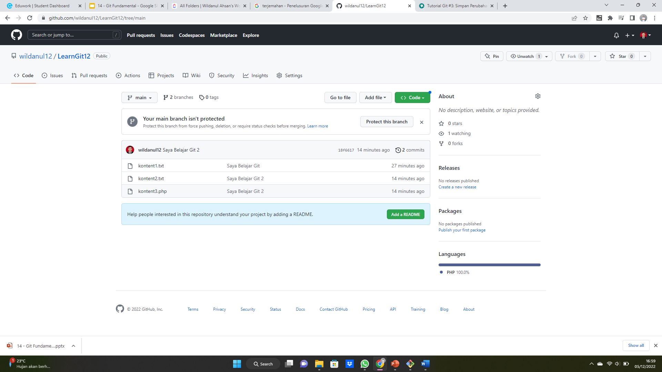

Gambar di atas branch main

------------------------------------------------------------------------------------------------------------------------------------------Gambar di bawah branch mytask

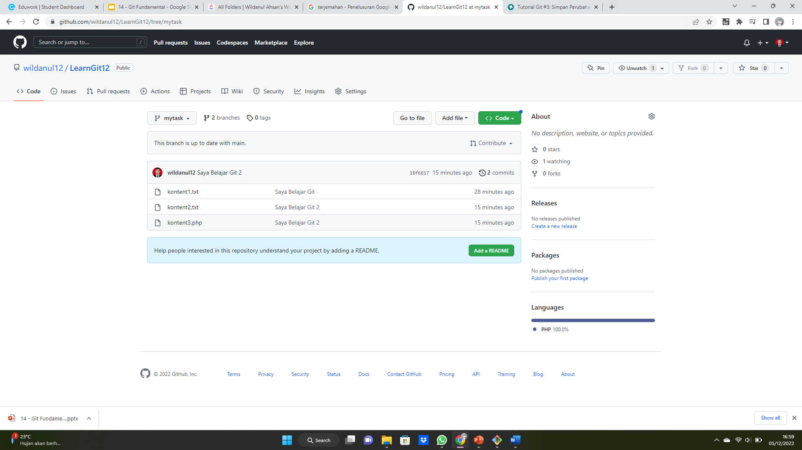

**Eduwork.id**

**Free Class – QA Engineering**